JIRA NOTES

A.MANOGNA

JIRA INSTALLATION

Open Browser:
https://id.atlassian.com/signup

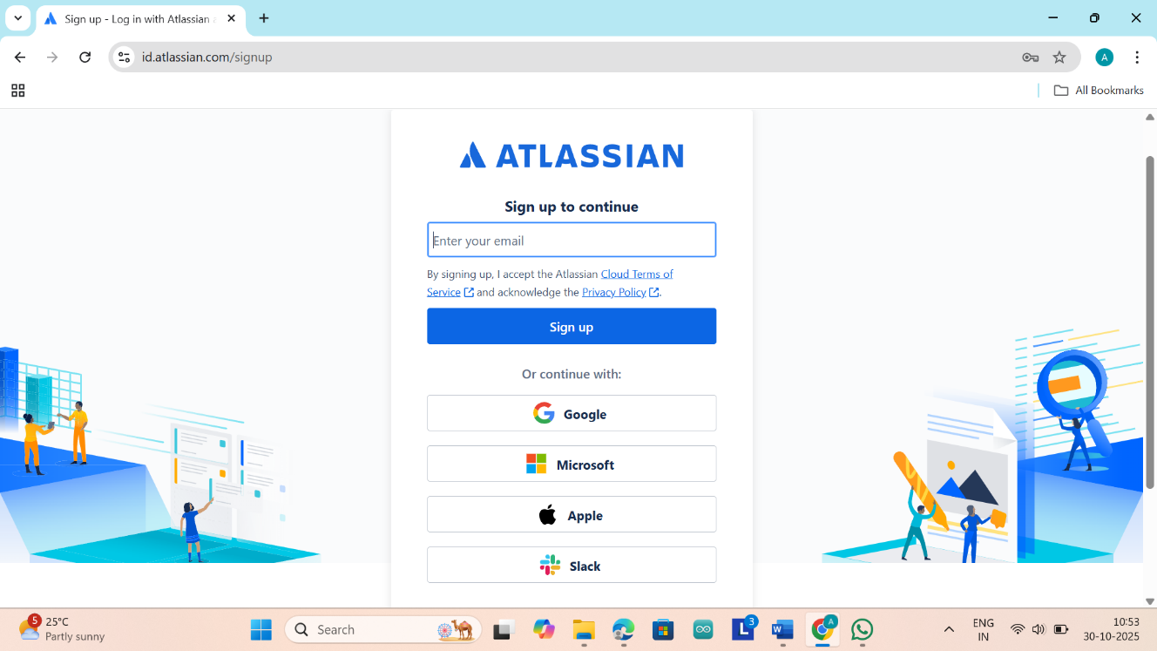

Now click on Google and continue with Email Account
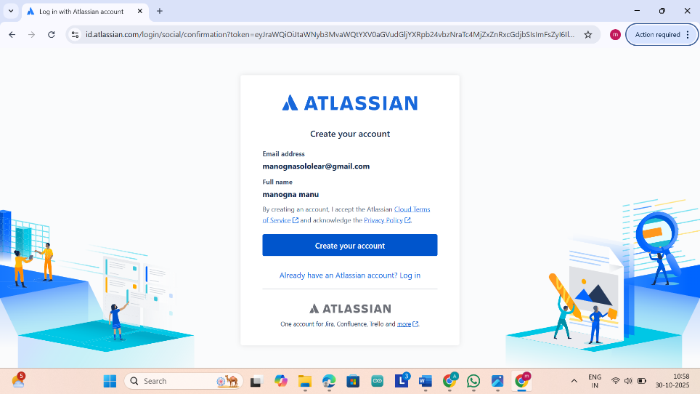
Then click on create Account
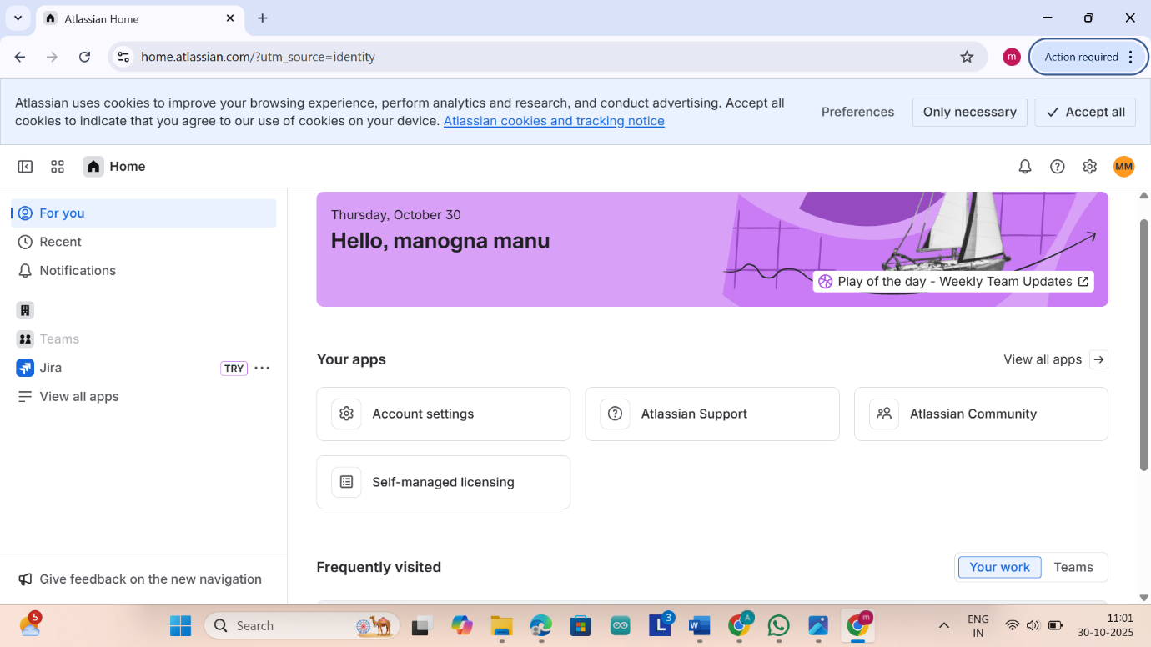
Then our Jira Account is Created
Then after creating just click on view all apps and we should click on Try Atlassian products and click on Jira and click on continue
And then select the Software Development and select work in scrum and click on continue
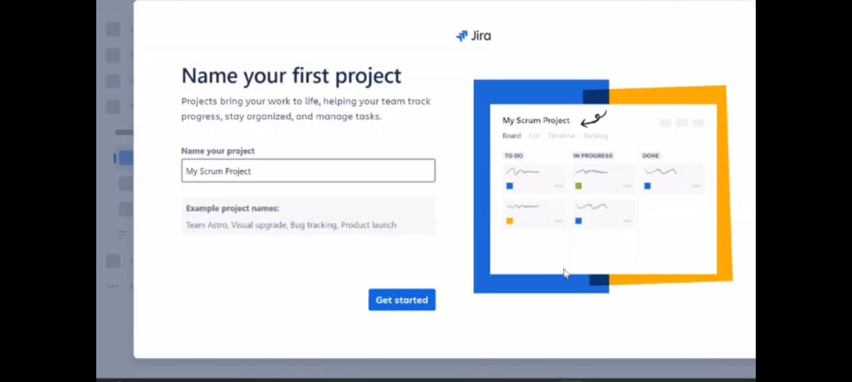
Then here we should give the name of the project and click on get started
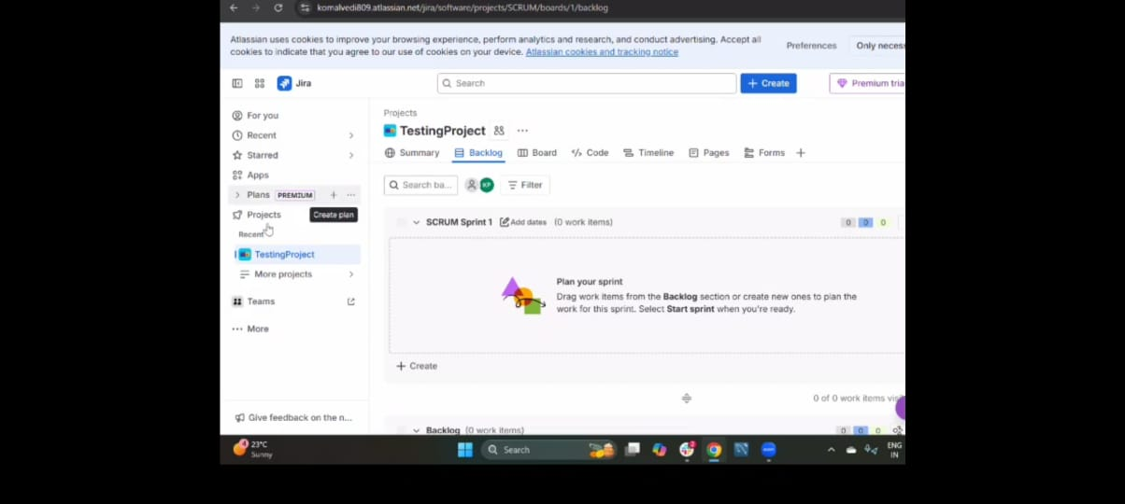
Now we can see that our Jira account is created
Here we should see the backlog option
Backlog is the task that you do in the sprint .
Now we should create a scrum assian project
on the left side we can see the option called project
Just click on the project there we can see the project templates
And in project templates select the software development
In software development select the Scrum
Scrum is an agile framework used to manage works in sprints
A sprint is where a team works to complete specific tasks from the backlog

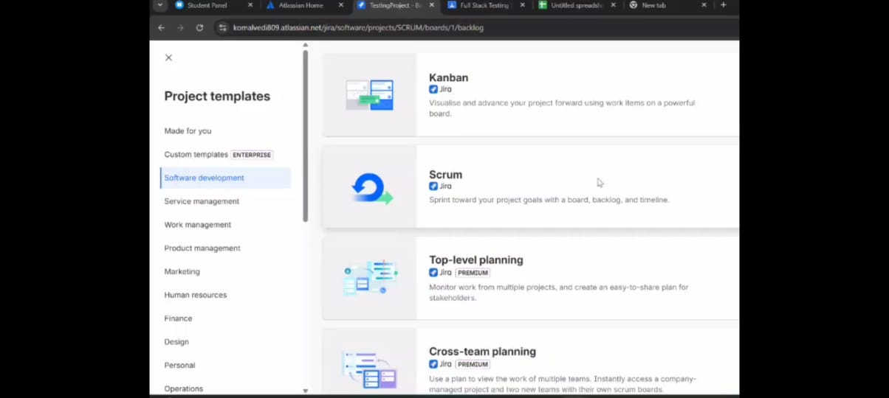

After selecting Scrum we can see that there is option called use template just click on the use template
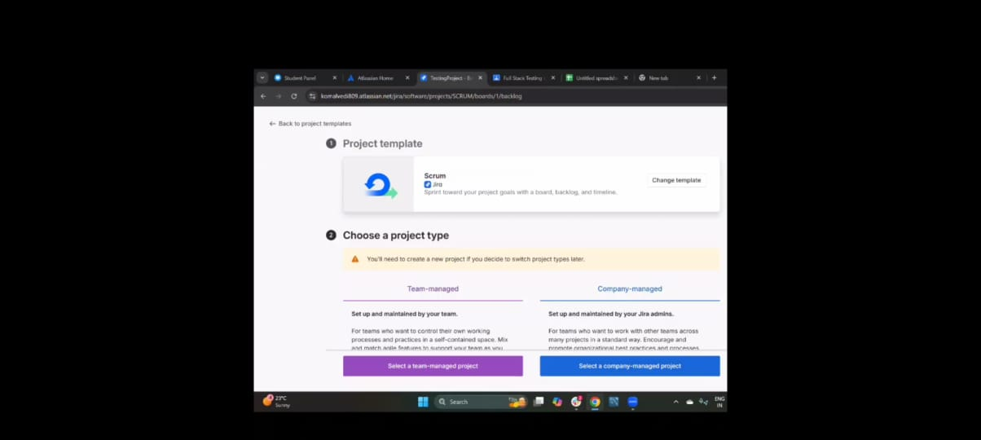
Here we can see the two options just select the select a company-managed project
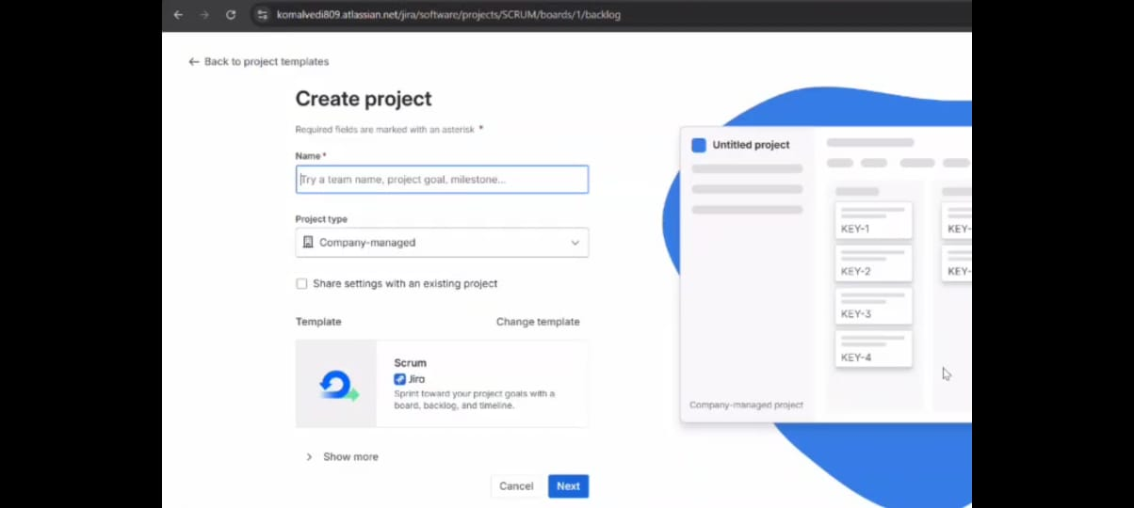
Here we should give the Name to the Project and click on next
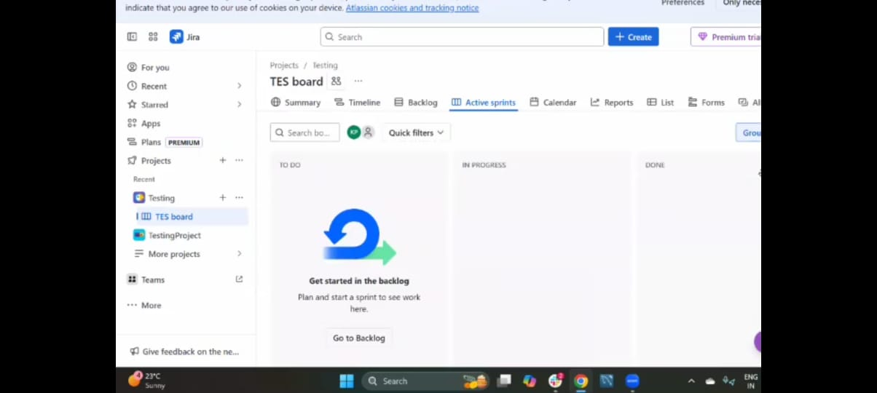
We should see the backlog and active sprints
If we see a backlog and active sprints at the top then our project is created successfully
Active sprints are the sprints that are currently running where the team is activity working on assigned tasks.

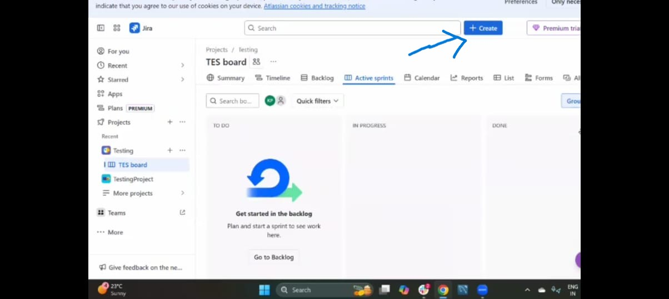
Here we can see the create option just click on it
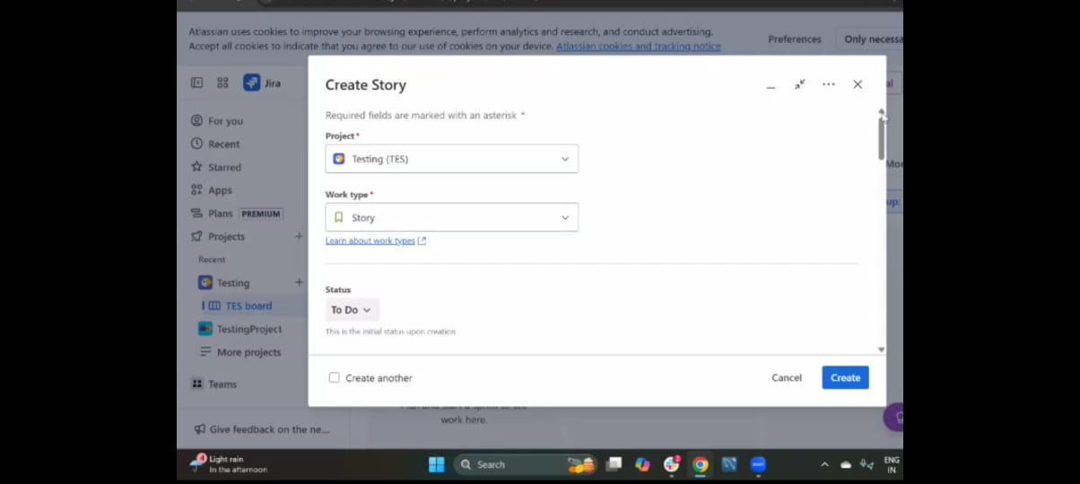

we should select the project in which project are we created the issue
We should select the project which have backlogs and Active Sprints
And in the second field we can see the work types there we can see he four work types there are
- Task
- Story
- Bug
- Epic This all are the Backlog items
Now we are selecting the Epic
Epic is the large amount of work which cannot be completed by one person it requires entire team to work on it.
Epics take entire sprint and it takes more time and it may not be completed with 1 sprint it may take more then one sprint
And the epic is divided into stories
And there will be a summary and we should write the summary for it
And there we can see the option called Status, in status we are seeing three option they are TO DO, IN PROGRESS, and DONE
TO DO :- whenever we are creating the issue it will be in TO DO status
IN PROGRESS :- you are started your work
DONE :-you have completed your work
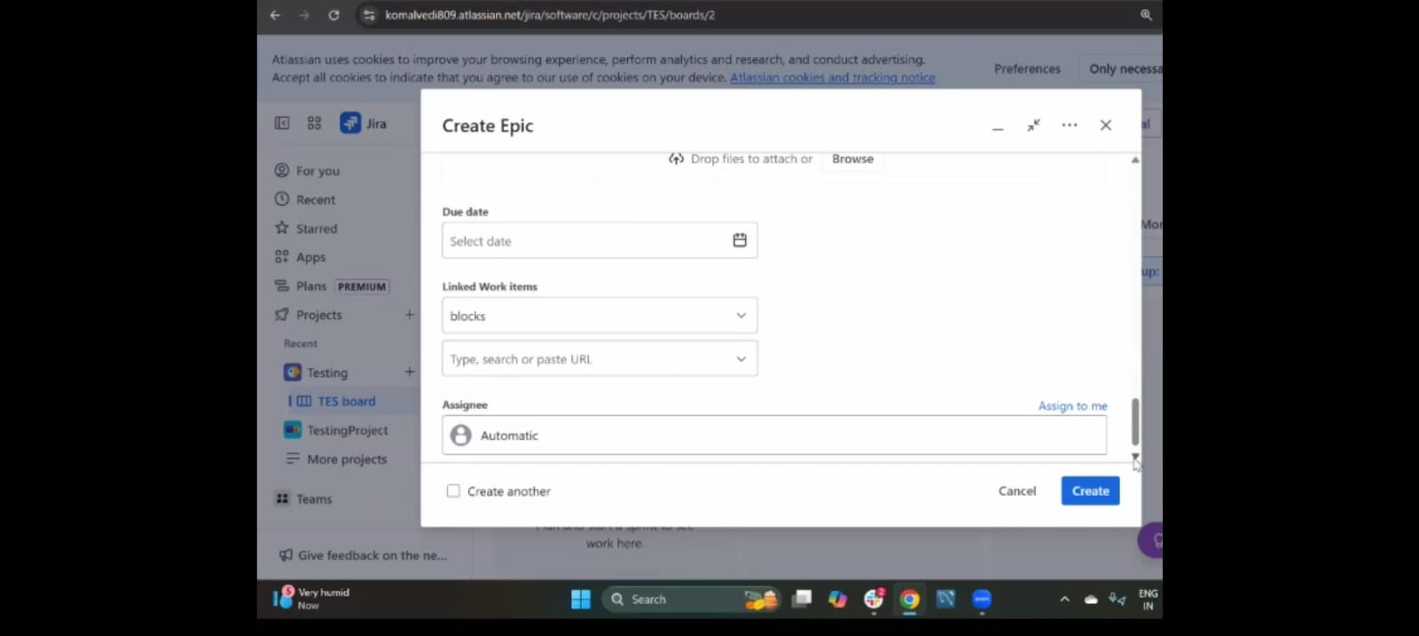
Due date is like when you should start and when you should end.
Assignee is who ever responsible for working for the backlog item.
After filling the details just click on create .To see our epic which has been created go to backlog section there you can see the epic.
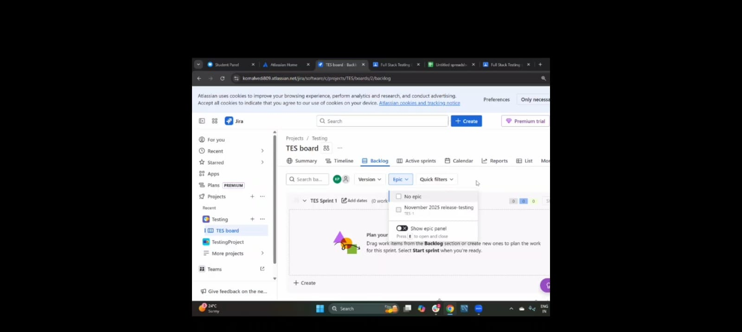

This is how we can create the EPIC
We can see the Epic on the left side of the backlog screen
And we can the more option on the screen just click on the more option there we can Filters , Dashboards and click on filters and select All Work Items
This will show all the list of the work items that has been created so for in the project
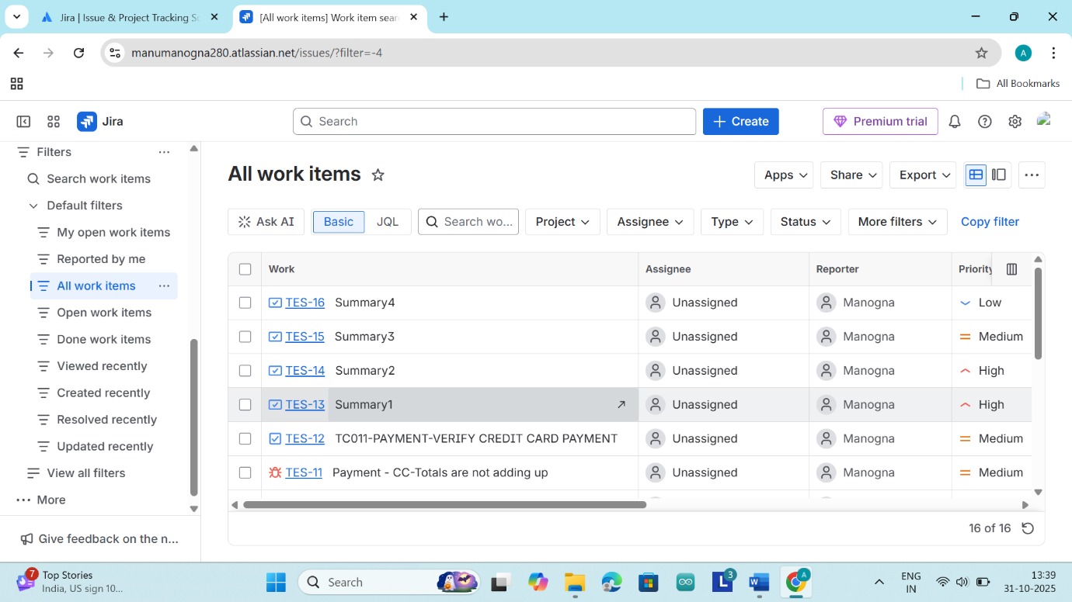Here we have two types of Filters there are Basic filter and JQL(Jira query language) filter the JQL will be similar to the SQL
Now we should go to our project named TES board and go to backlog and expand the Epic and there we can see the work items and there we should see at least 1 or 2 work items
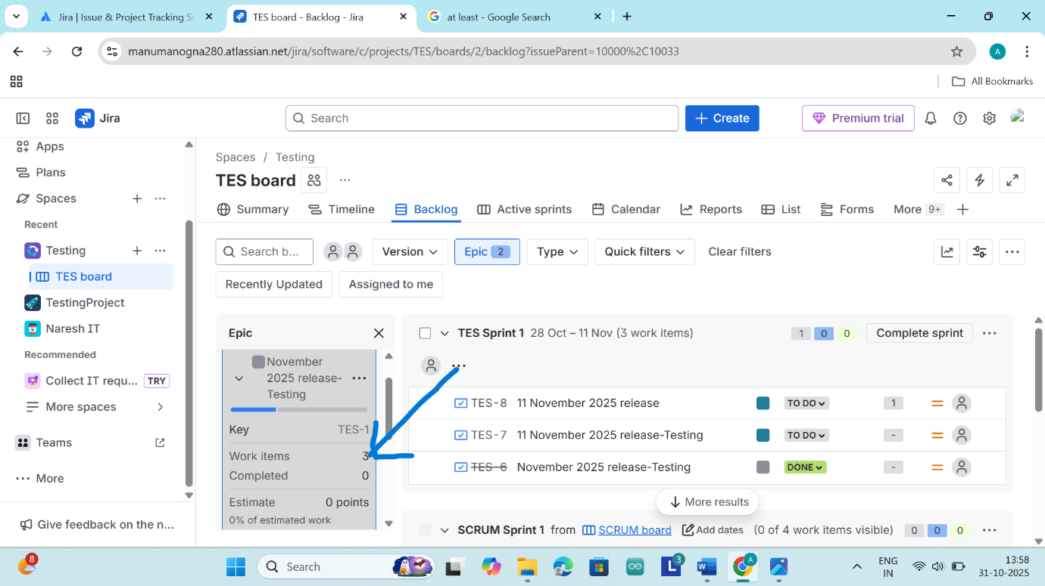
Here under the backlog section we can the see our stories which we have created
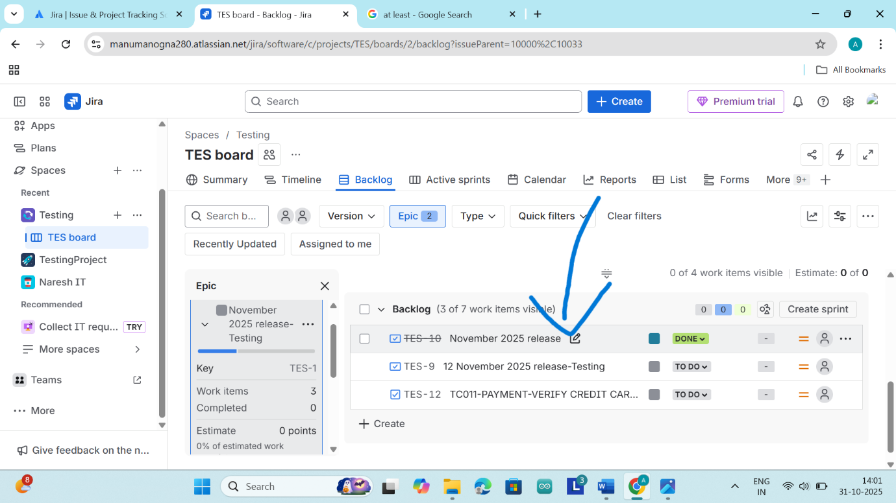
Now we should open any story from the backlog and when select the story immediately a screen will be pop up
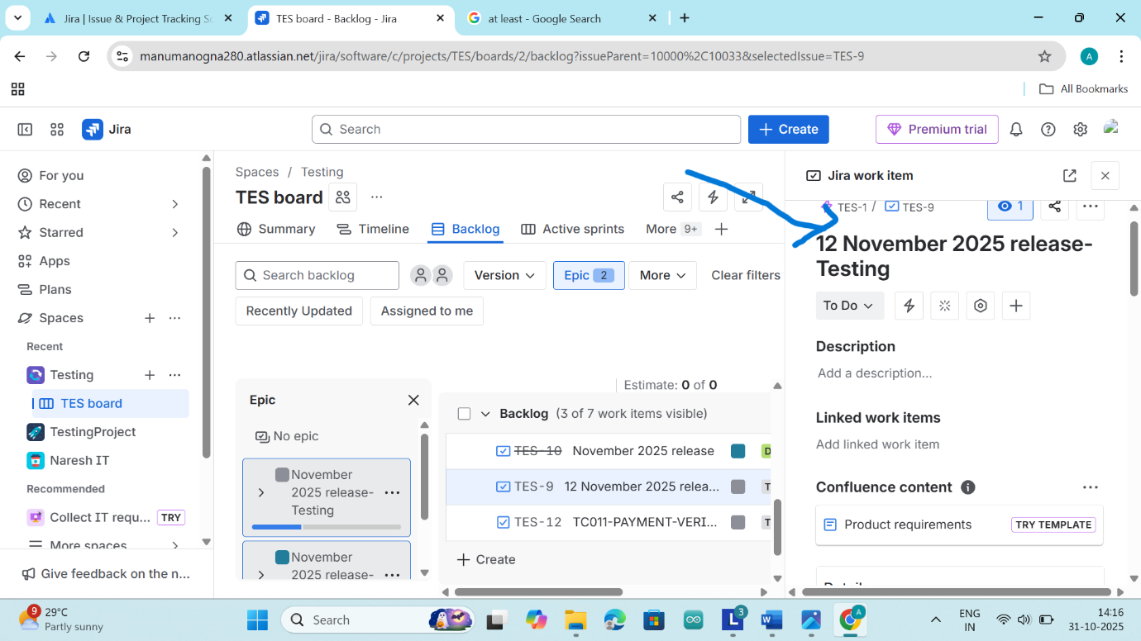
In the screen we can write the description here when we scroll down we can see the option called parent there we can select the parent
Here we are linking the both Epic and Story by using the parent
There will be a one epic for entire team and when we select the Epic from the all work items we can see the child work items
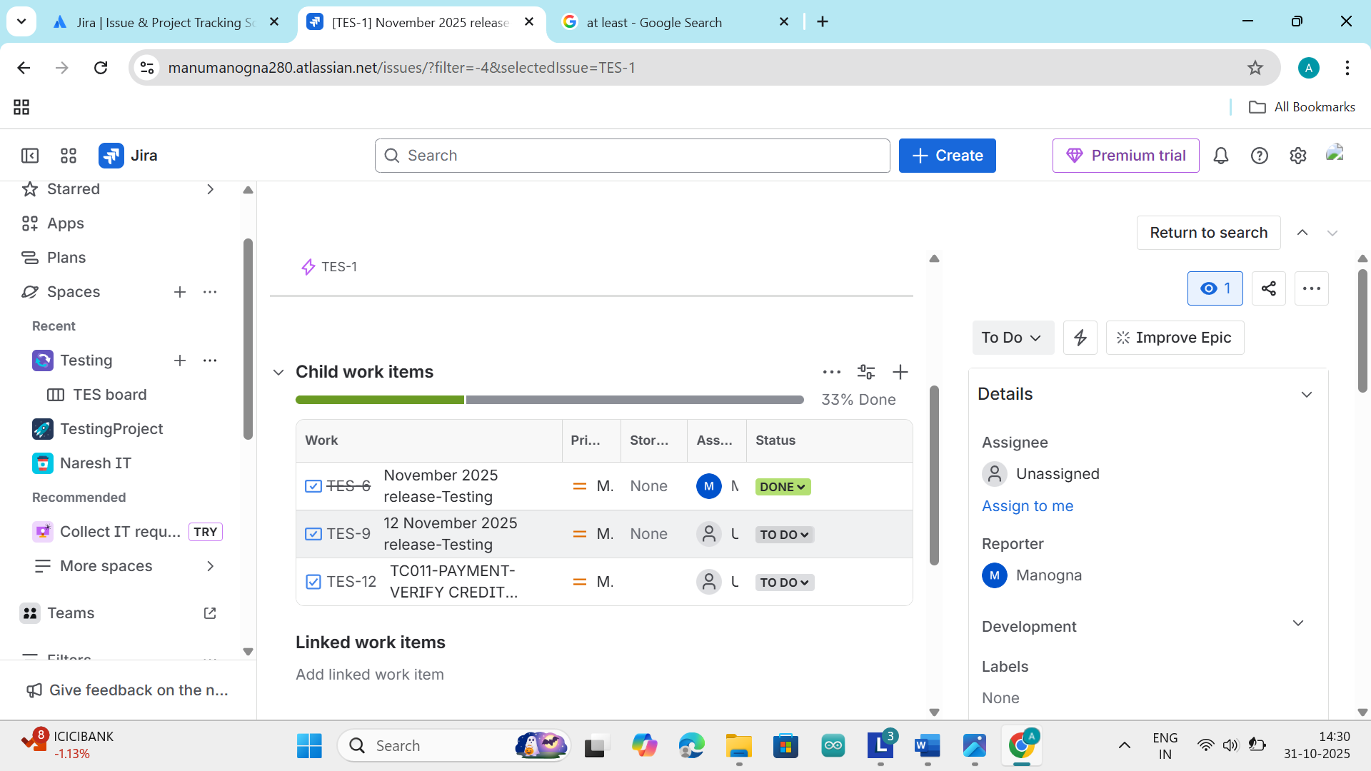

To complete the epic we should complete the all work items
SPRINT:-
Sprint is a time period
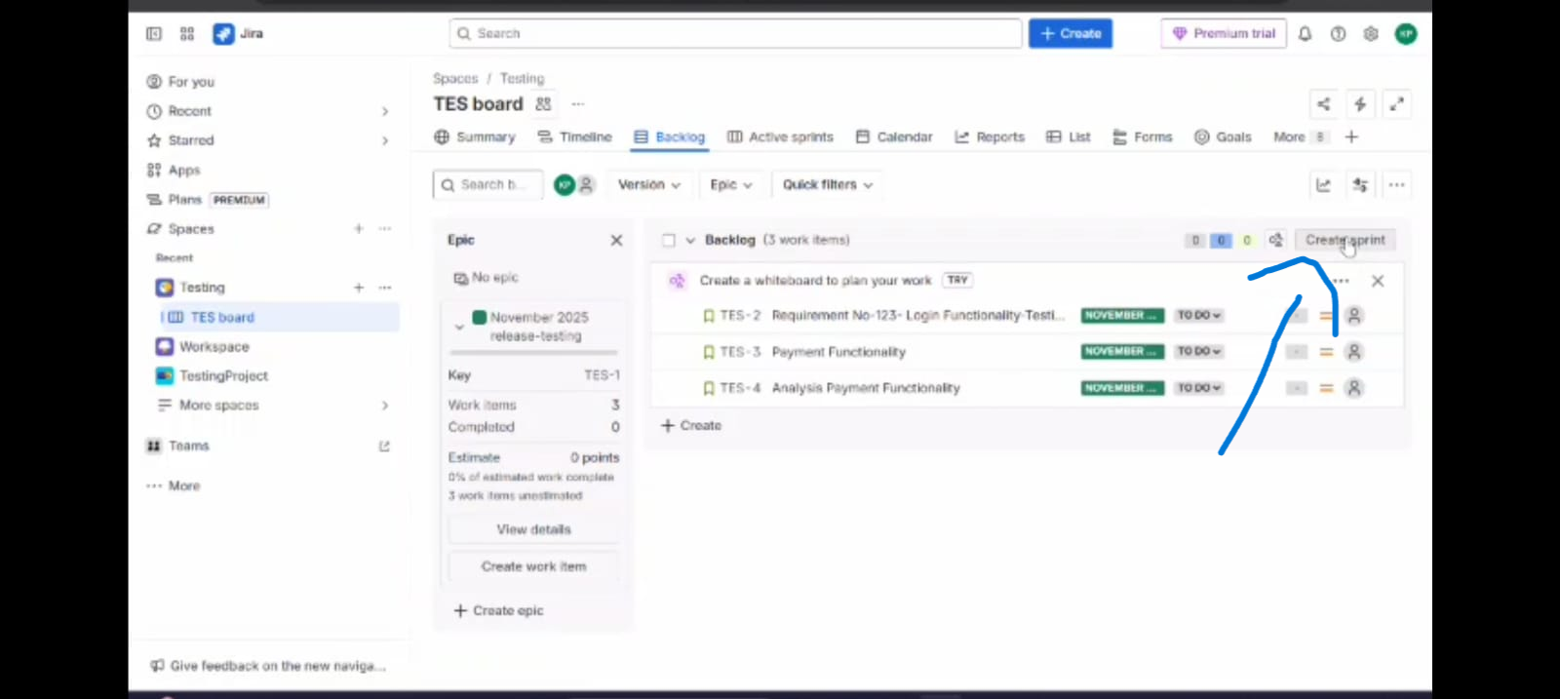
We should create the sprint by using the create sprint button in the backlog
By clicking the button the we can see the sprint1
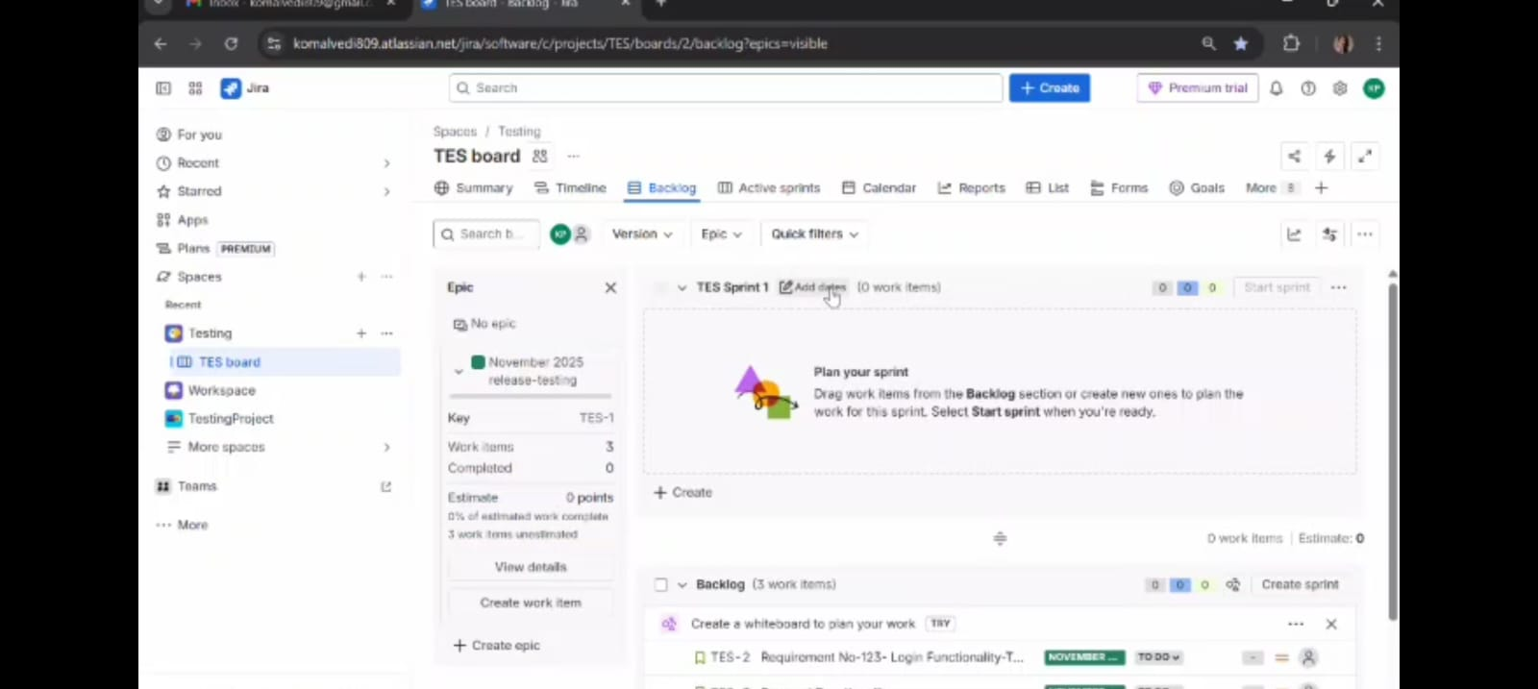
Beside the sprint1 there we can see the three dots and just click on three dots and select the edit sprint
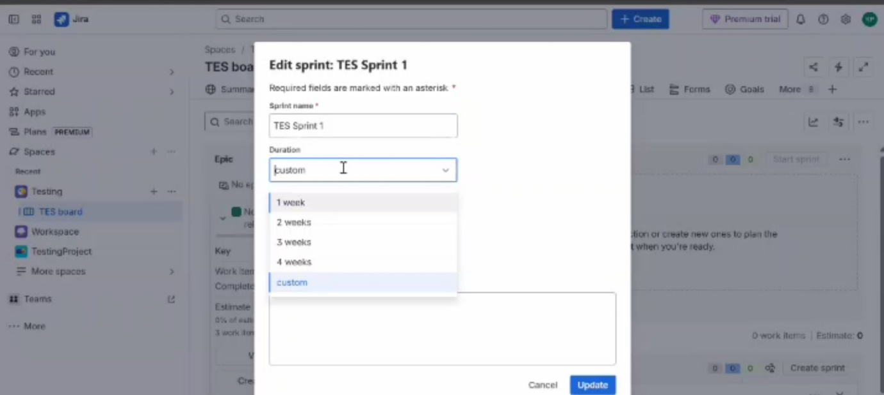
Here we should give the sprint name and in the duration we should select the time period and we should give the start date then automatically the end date will come and in sprint goal we should write the sprint tasks
Now we should drag and drop the story from backlog to sprint1
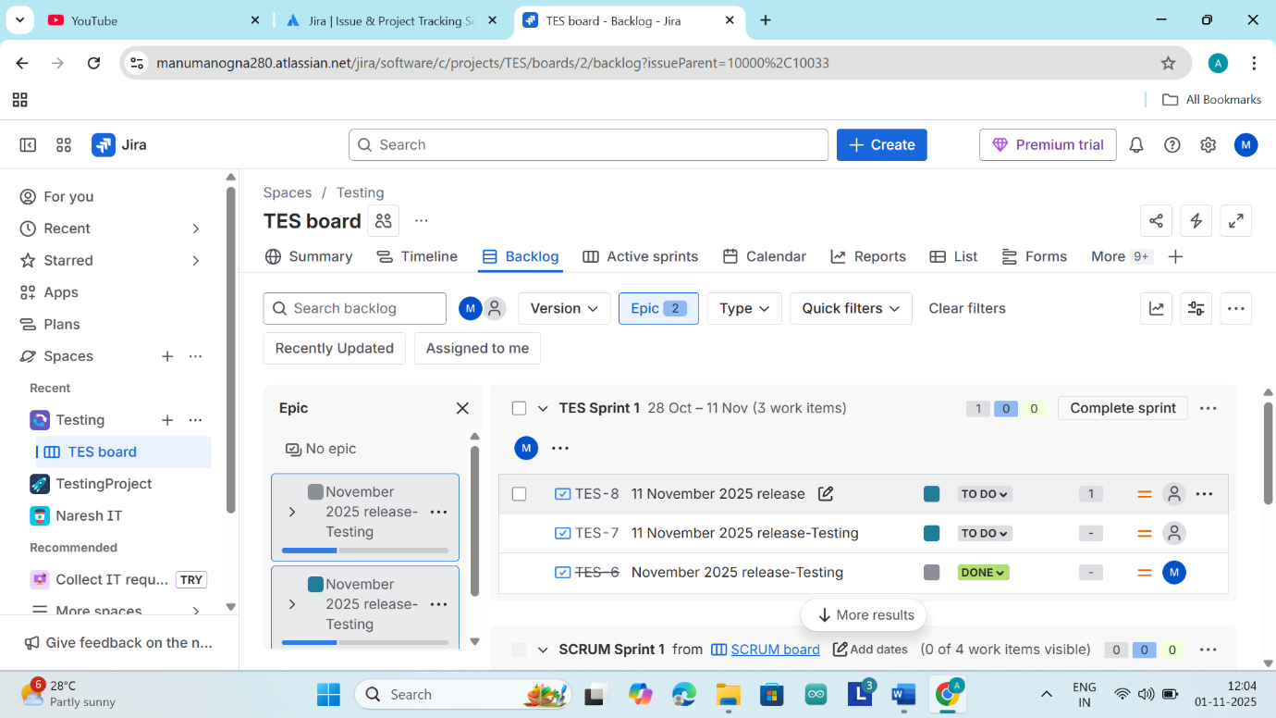

Then here we can see that the stories are added to the sprint1
In the active sprints we all see our backlogs
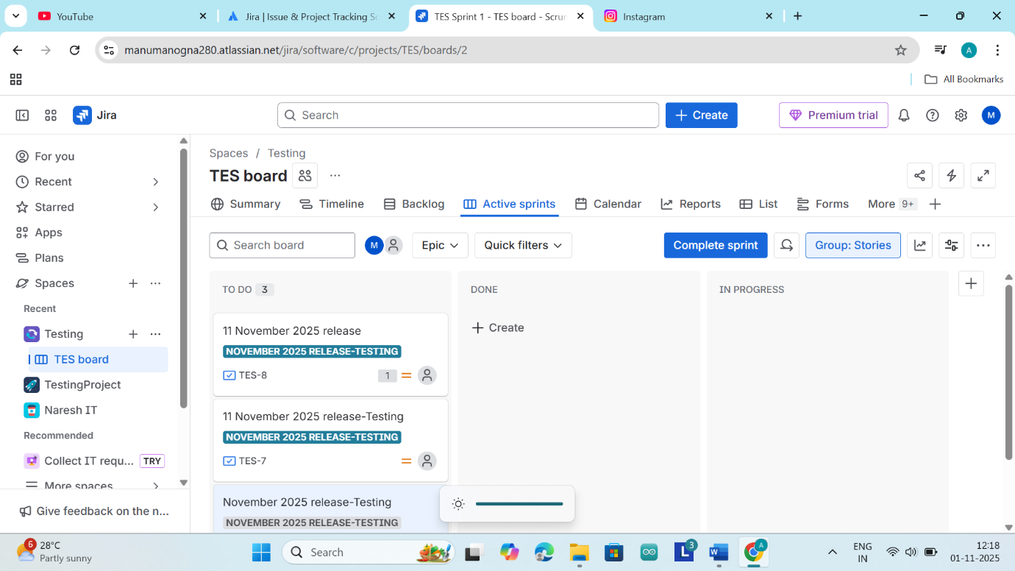
Beside the complete sprint there is a small option called sprint details there we can see the sprint details
In the Active Sprint we have three section there are
- TO DO
- IN PROGRESS
- DONE
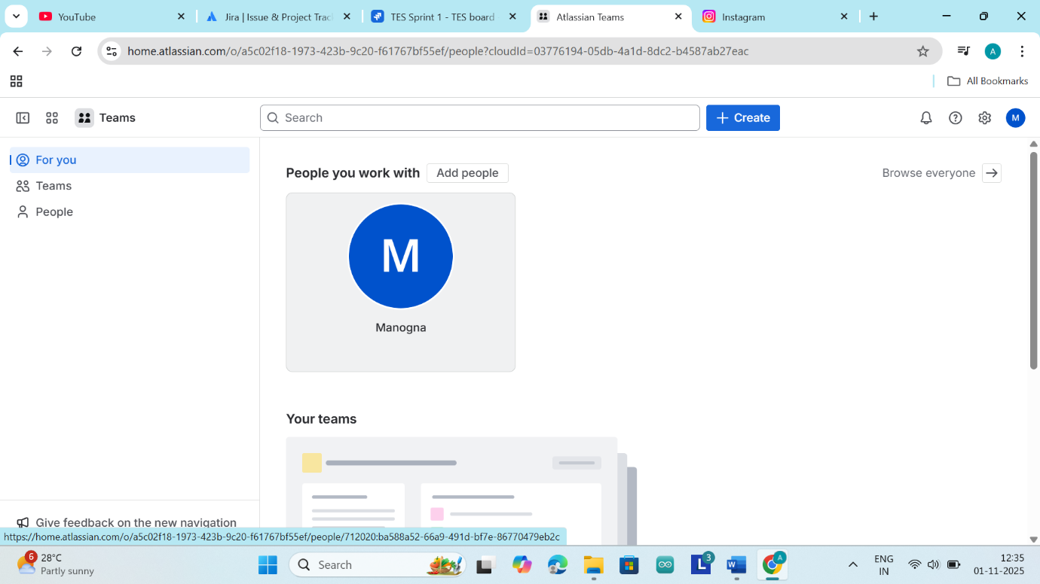

Here we can invite our team members and we can see the people option there just click on people and there we can invite our team members with there email id
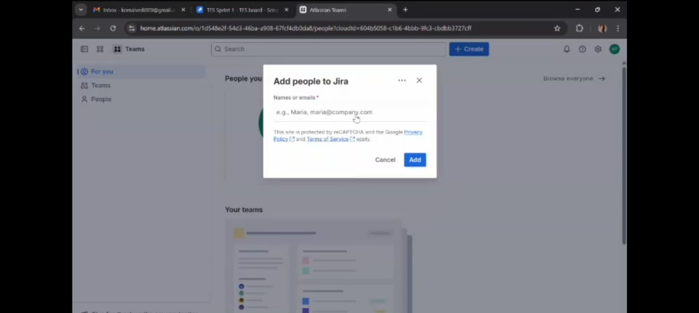
We can see the invitation in our email inbox
Now we should add Zephyr in Jira to add Zephyr to Jira we should go to apps and we can see explore apps then click on it we can see
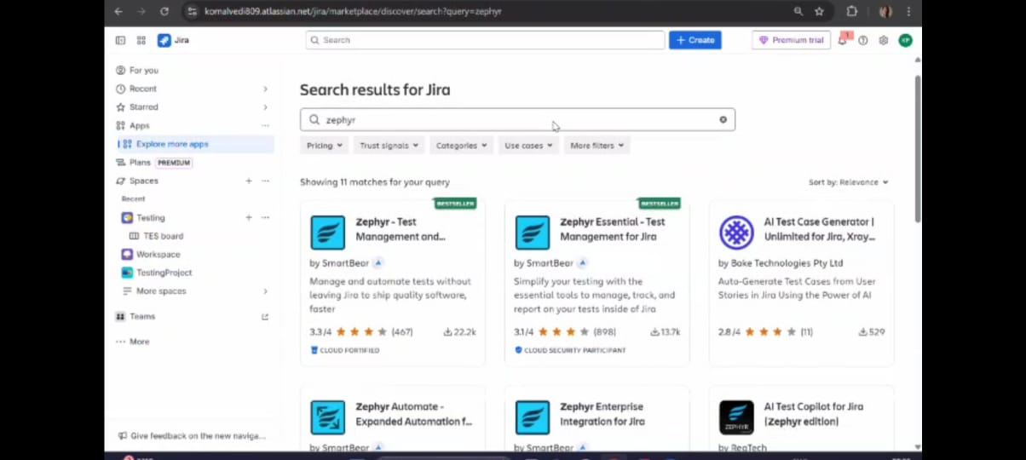
Click on first one Zephyr test management and click on try it free
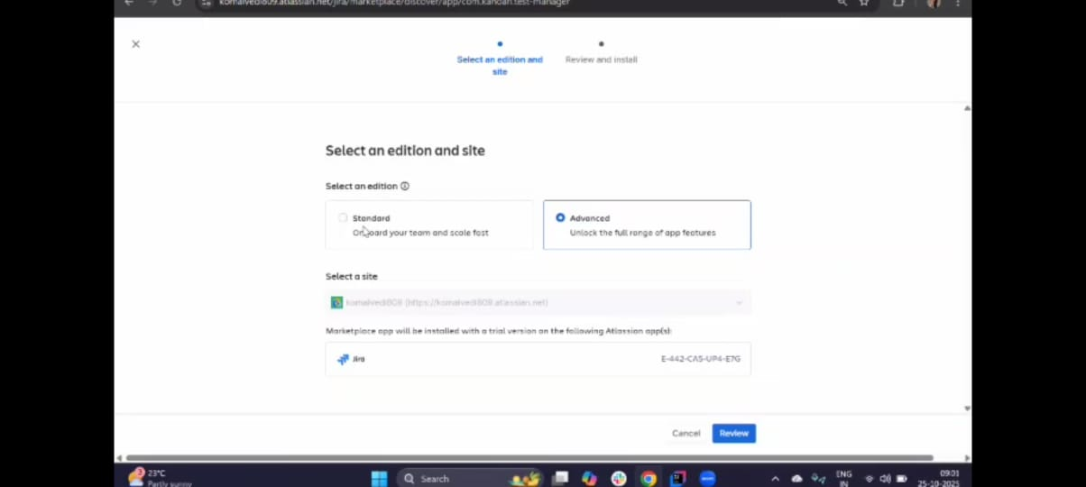
We can see screen after clicking on the try it free just, click on review and click on start free trial then its done and it add to the Jira
Now go to more and click on Dashboards in dashboard we can see the stories which are assigned to me
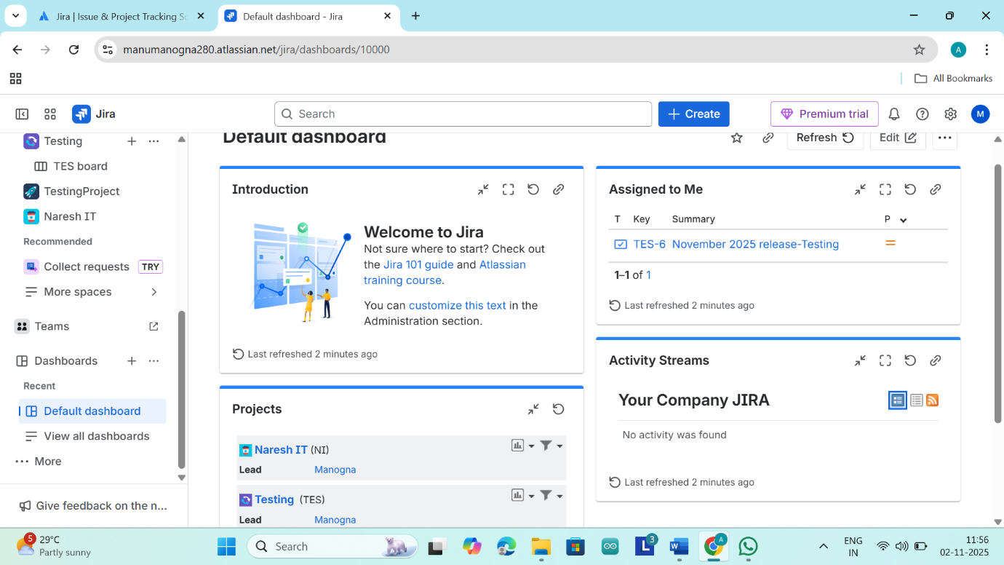
Now we are creating a bud by using the create button
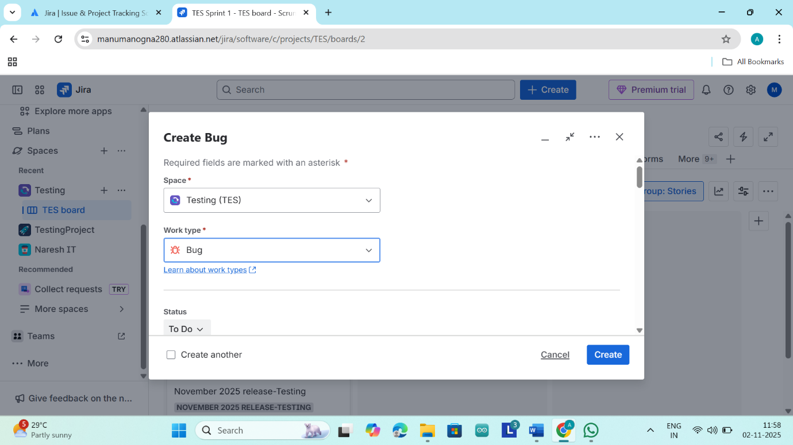
Here we are changing the work type into bug and click on create
Then the bug is created
To create multiple issues you should go to more and go to filters and go to all work items
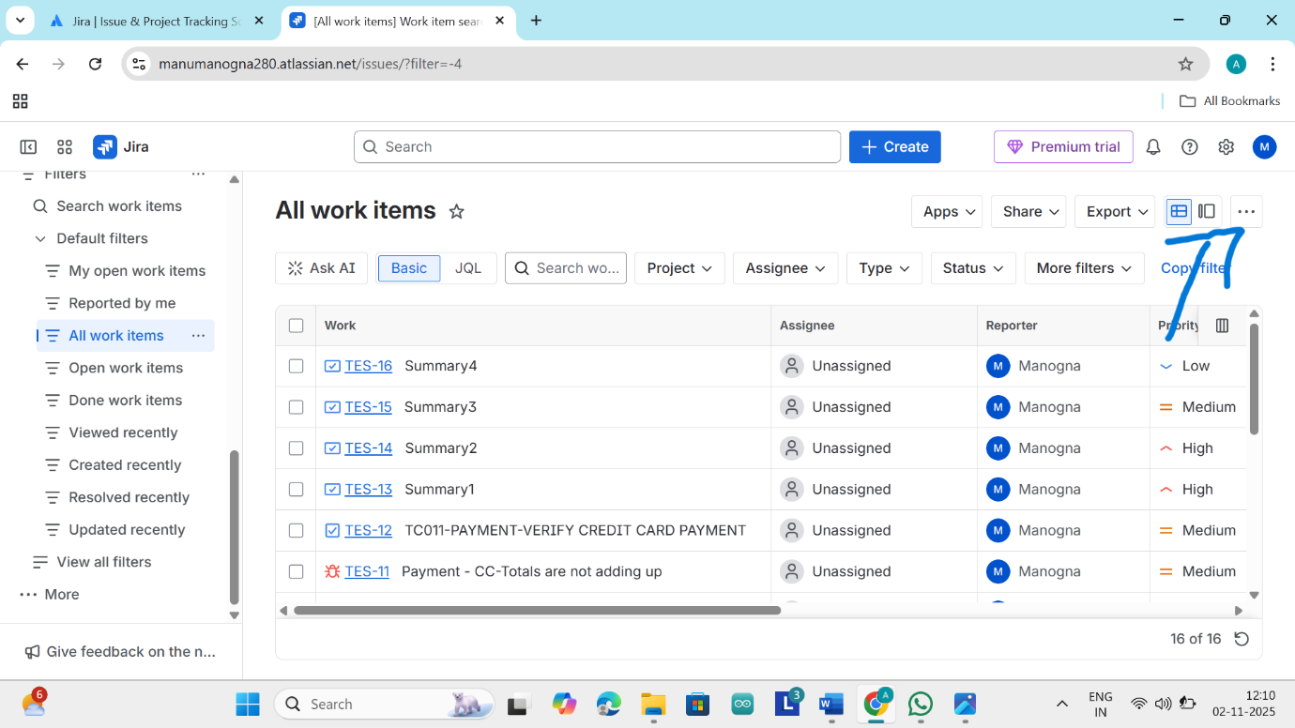
Now click on that three there we can see the option called import work items from CSV just click on that there we can see the screen like this
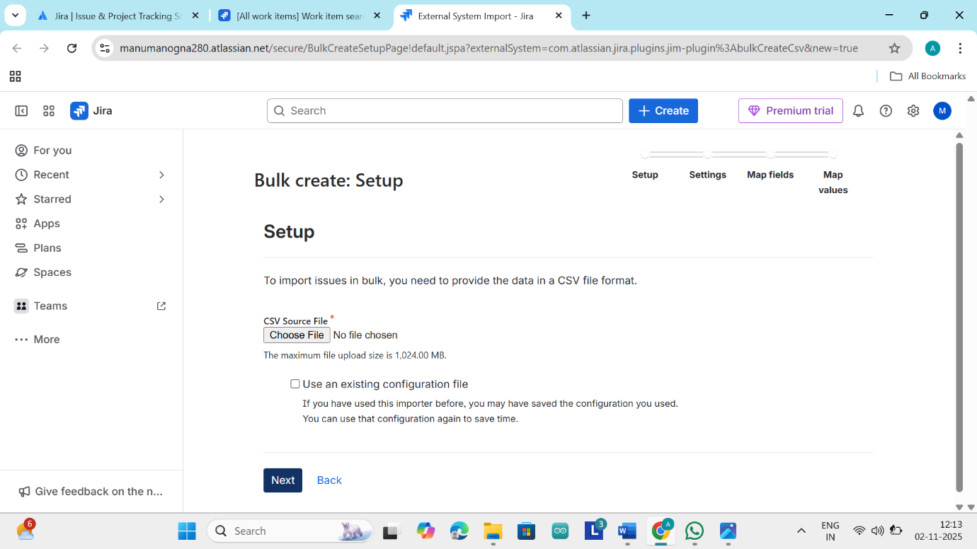
We should write our test cases in csv files then upload the Jira then all test cases will be imported to Jira and click on next and select the project and click on next there we can see the map fields.
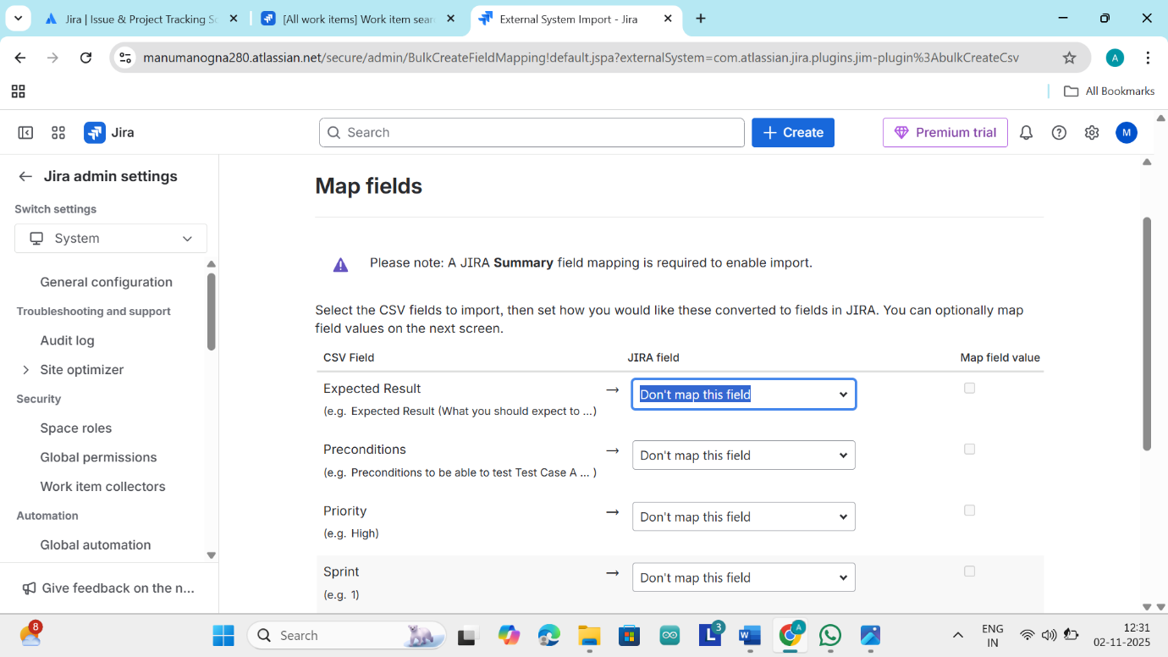
Here in the Priority we will map to priority
Here in the Sprint we will map to Sprint
Here in the Steps we will map to Description
Here in the Summary we will map to Summary
And click on next there we can see map values
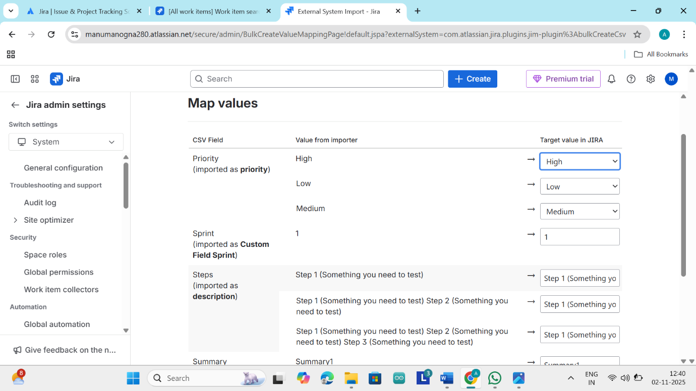
Next click on begin import
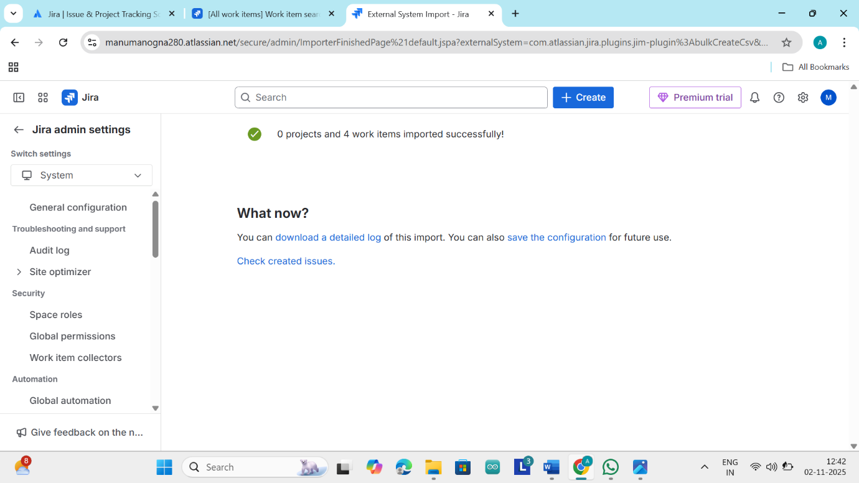

It is importing the issues from the CSV file now click on check created issues
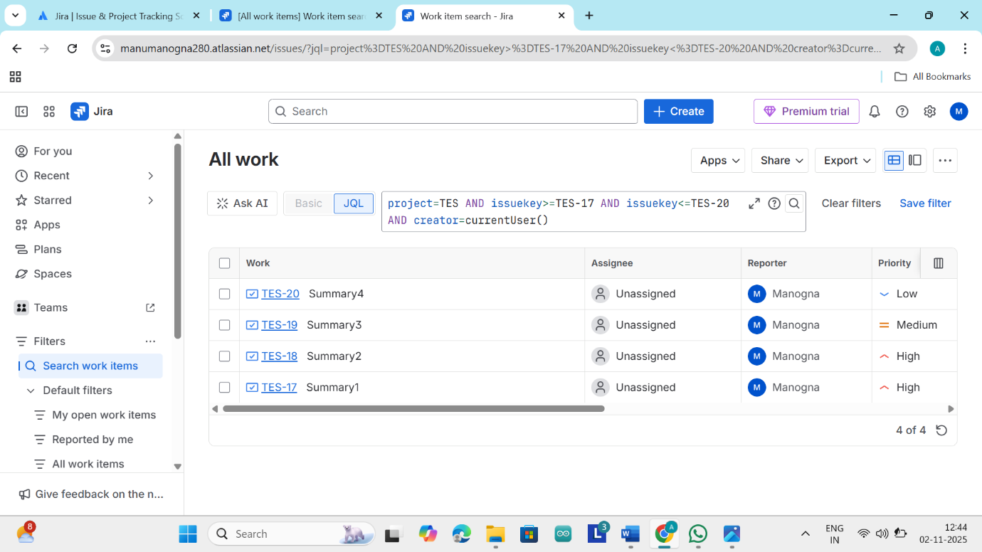
Here we can see the issues we has been created from the CSV file
If we want to assign the 4 tasks to one person and we want to put it one sprint
Again click on this three dots now go to bulk change work items
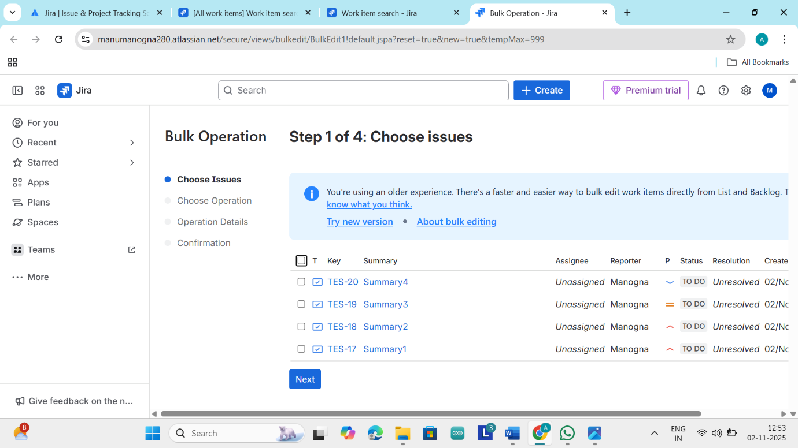
Select all the stories and click on next
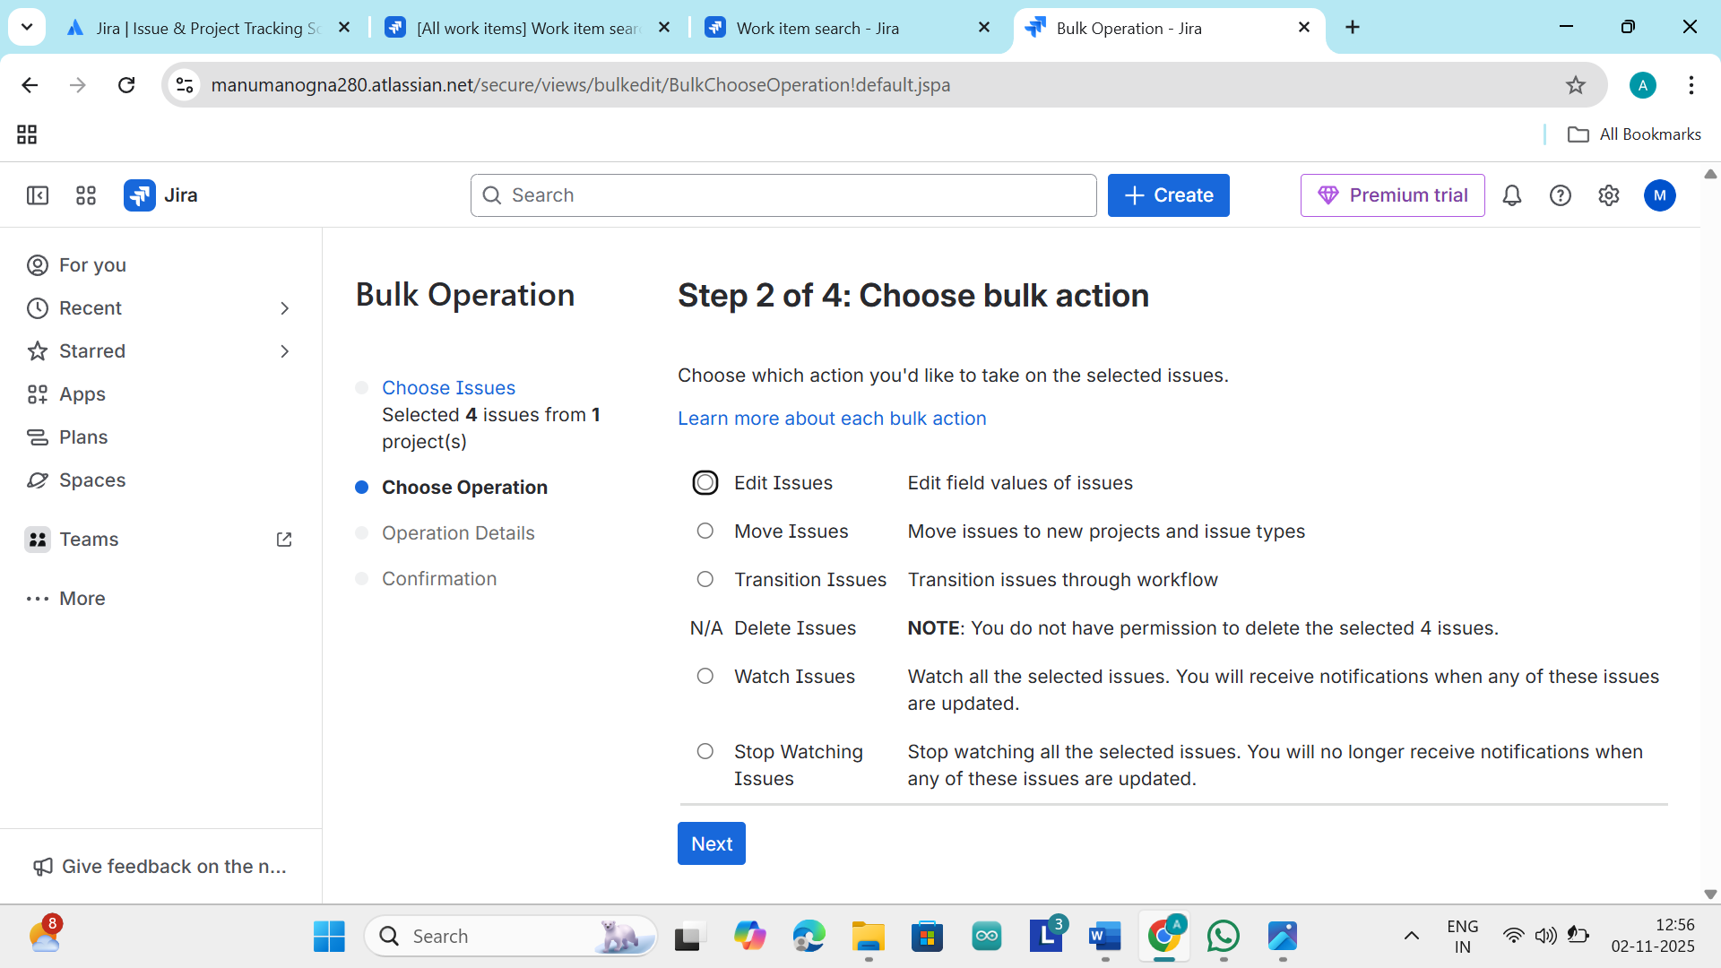
In second step we should update the bulk here click on edit issues and click on next
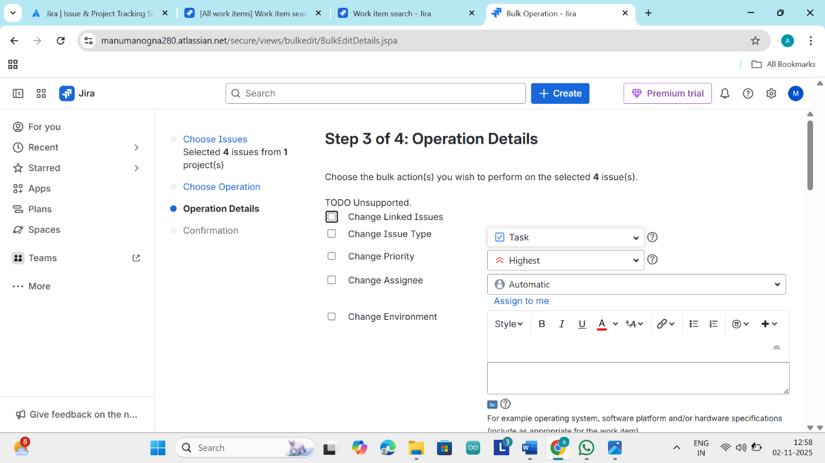
In the third step here we changing the priority high for all of them
Here in this step we should update all
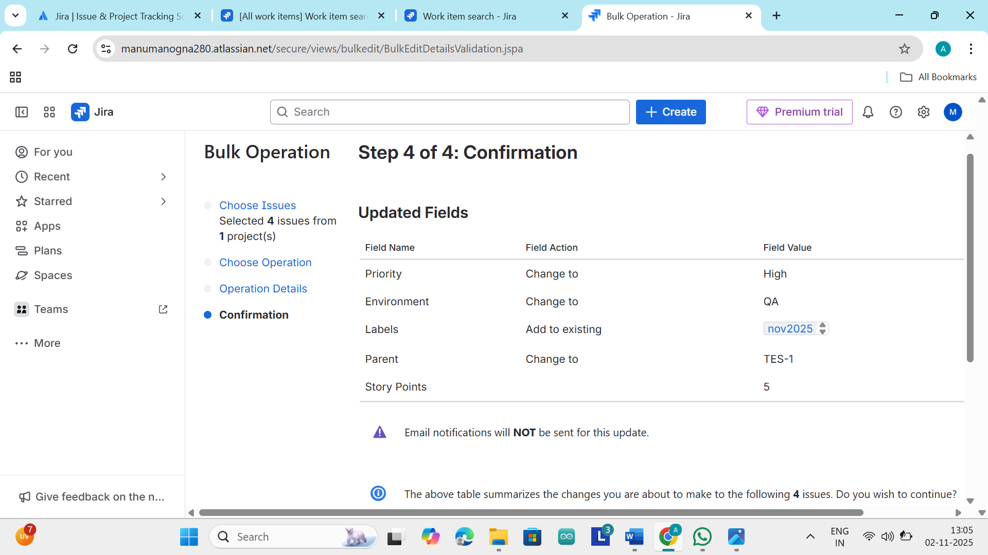
This is the final step which is the confirmation and just conform it
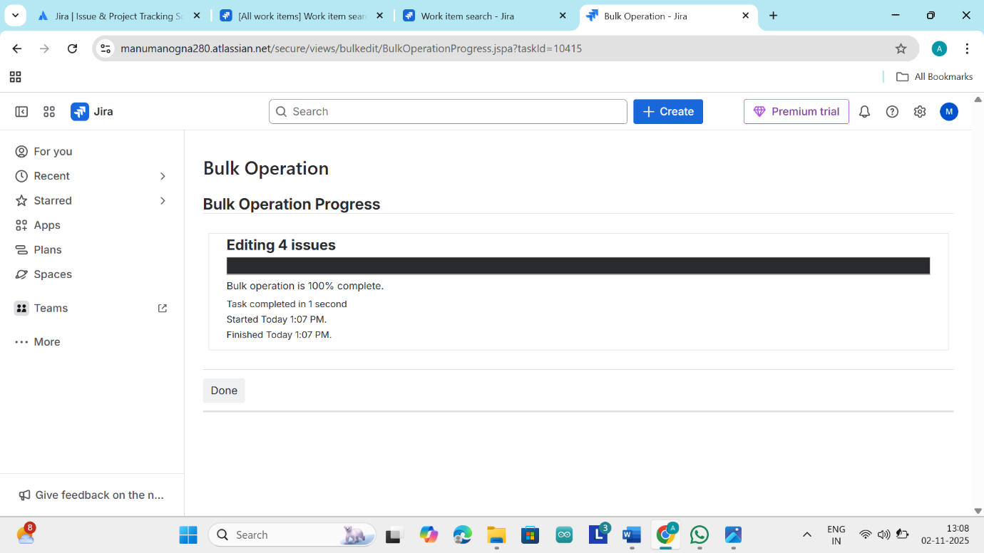
We get screen like this
Now go to apps and click on Zephyr
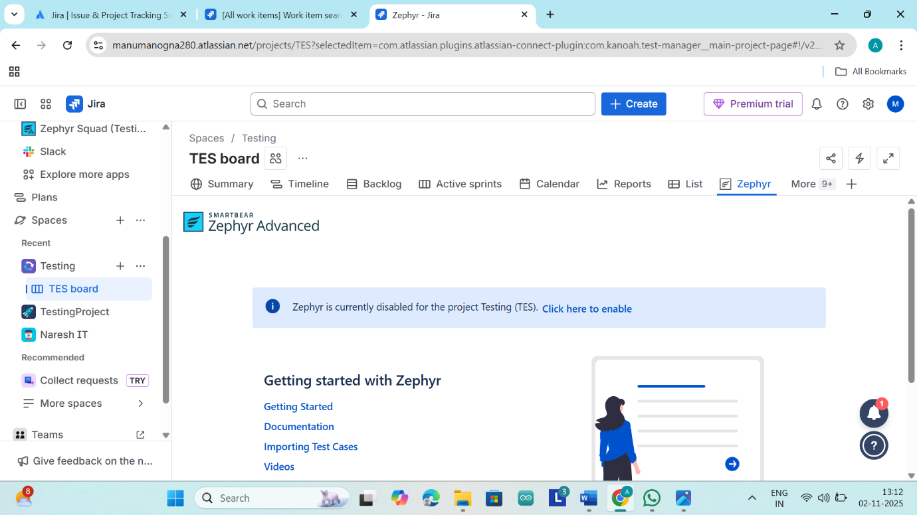
Then Zephyr can appear on the screen
It is a tool that is extremely developed to handle the test cases
It will manage the test cases
It is a test case management tool
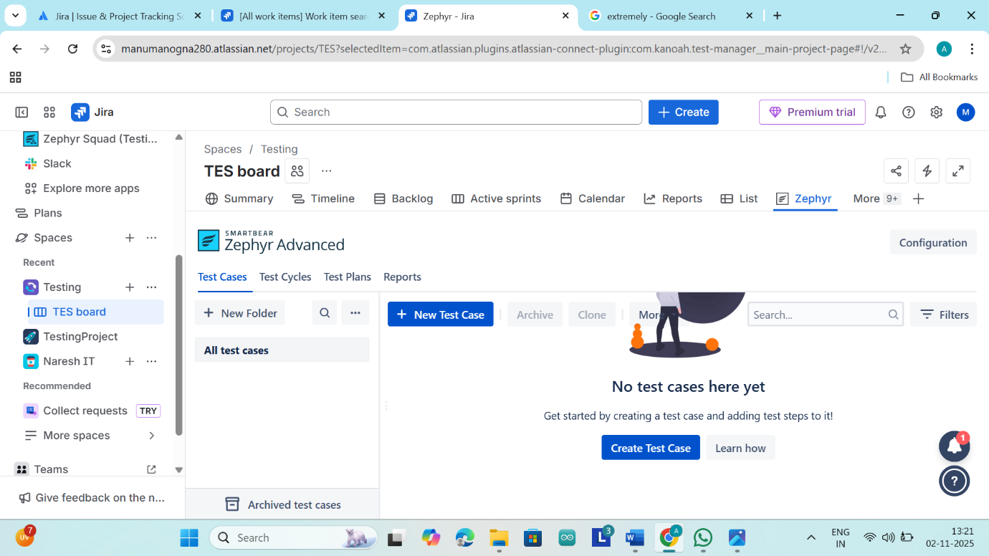
Here there is a option called new test cases just click on it and create the test cases
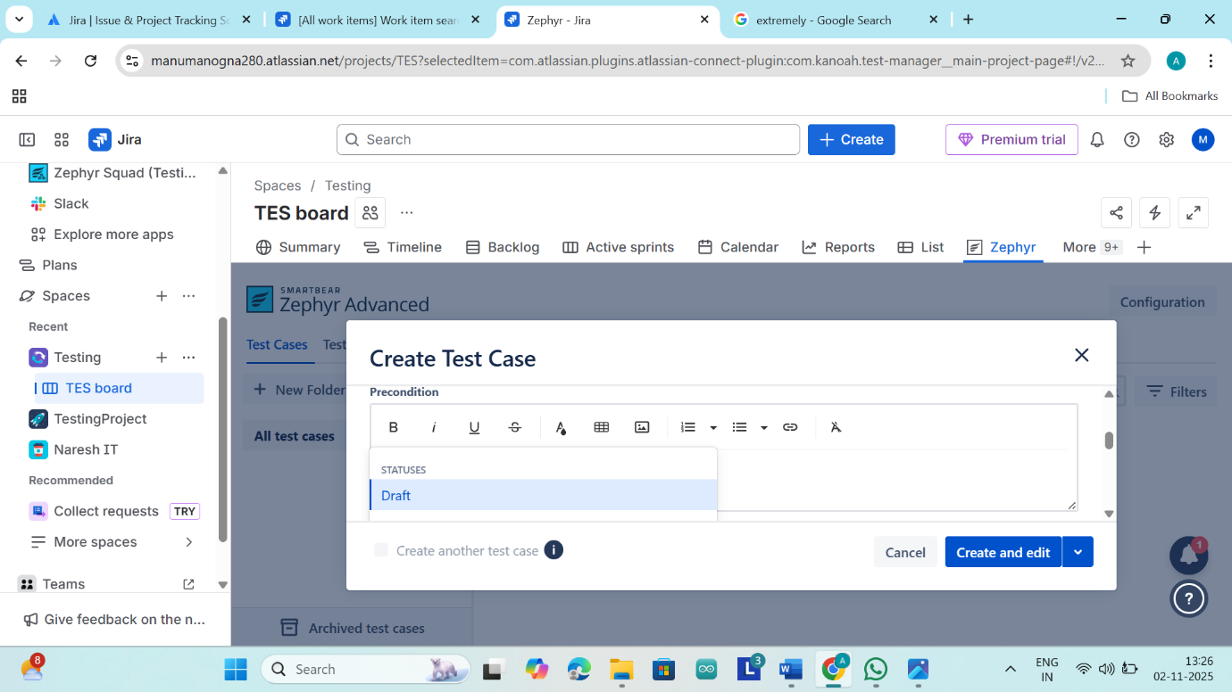
Here we should give the project name
At there we can see the status option in status we can see three option called
Draft :-whenever a new test case is created it will be in draft
Deprecated:- it is no longer applicable
Approved:- it is final
After filling the details click on create
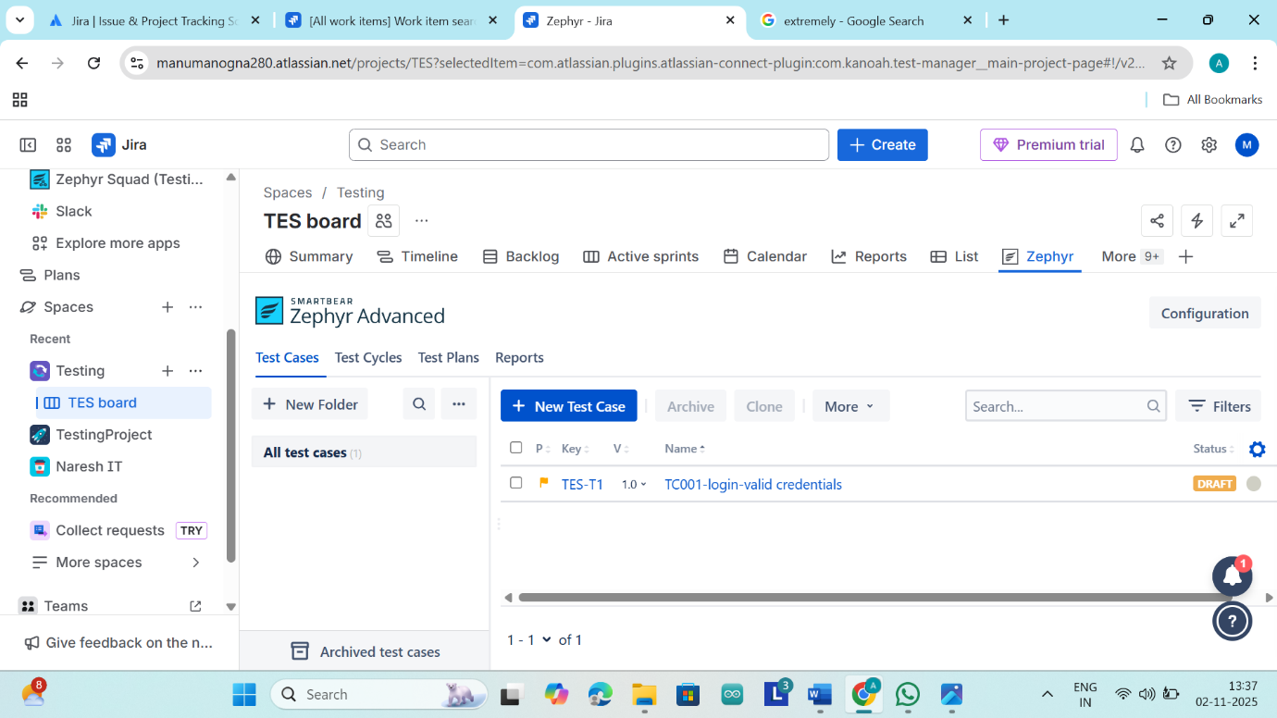
Then our first test case is created
Just click on test case and go to test script
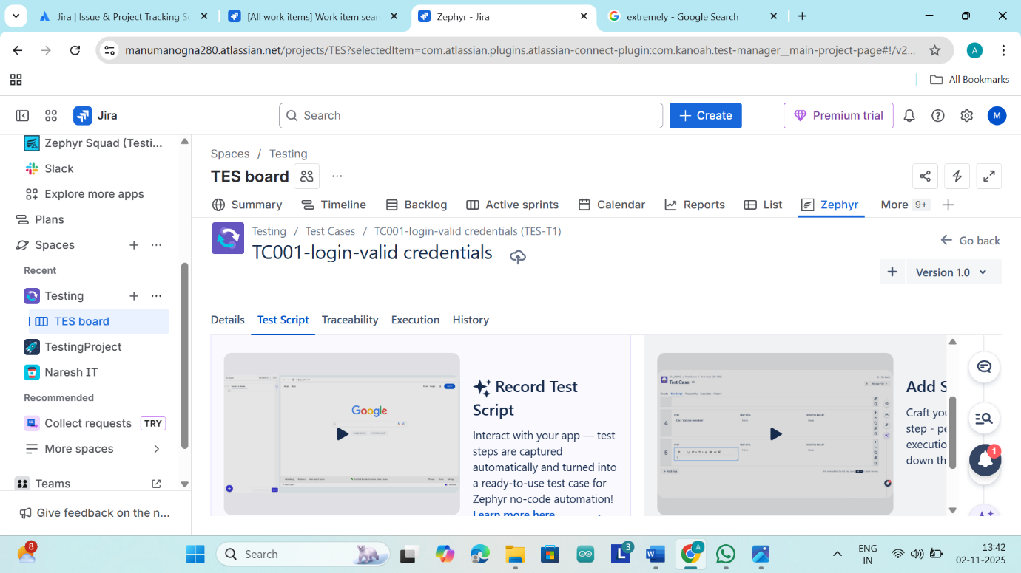
Here we can see that there two scripts
- Record test scripts: it will be captured by itself
- Add steps:-here you need to add the steps manually
Now click on add steps manually
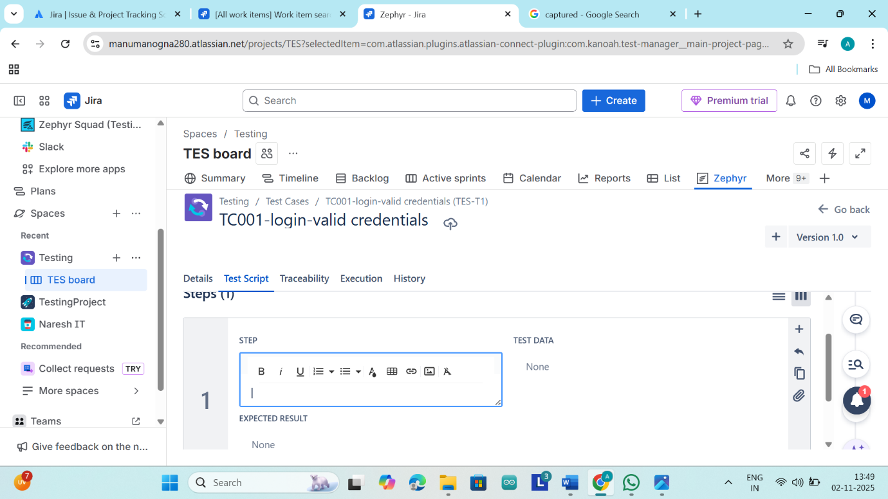
Here we should write the steps manually
In step one open the application and beside of it there is a test data in test data just type URL
Here there is a expected result in that the expected result should be the application should be open and in the second step add enter user name
And test data type tes123
And the expected result be user name should be provided
And go back to details then we can see all the details

